2/23/2018

The Minnesota Athletic Trainers’ Association (MATA) is an allied health professional association dedicated to enhancing the quality of health care for the physically active through the promotion of professional growth, educational enhancement, as well as, the recognition of certified athletic trainers and their value as health care providers. With your generous support, we are able to complete this mission. We would kindly like to ask for your support for the 2018 year.

In 2018 the MATA will be hosting the 26th Annual MATA Golf Tournament and Dinner on June 20th. This event provides a great opportunity to meet Athletic Trainers, Physicians, Vendors, and friends. In 2018 we will again be offering a “Naming Sponsor” option for the Golf Tournament. We will also be offering the “Featured Sponsor” option again this year which will allow you to be a presenting sponsor at all of our events, receiving many benefits associated with each event, including links on the MATA webpage! ALL sponsors who support the MATA with $1,000 or more in 2018 will have their organization’s logo with a direct link to your website on our MATA homepage: www.mnata.com.

If you are a past sponsor of the MATA we thank you for your generous support and hope that you will continue your sponsorship into the 2018 year. If you are new to our list we hope that you will consider a sponsorship that best fits the goals of your organization. If you have any questions or concerns please feel free to contact myself or any member of the MATA Executive Committee.

The following are the 2018 sponsor opportunities:
- 2018 MATA Quiz Bowl and Student Symposium – Friday & Saturday, January 26 & 27 at Bethel University.
- 2018 Annual Meeting & Clinical Symposium – Friday & Saturday, April 27 & 28 at the Duluth Radisson in Duluth, MN.
- 26th Annual MATA Golf Tournament and Dinner – Wednesday, June 20th at Bunker Hills Golf Course in Coon Rapids, MN.

Please see the attached sponsorship informational sheet and sponsorship form for full details on supporting the MATA in 2018. If you are interested in being an MATA exhibitor this year, please complete the attached form and return it to the address listed on the form as soon as possible. Thank you for your consideration and continued support of the MATA.

Sincerely,
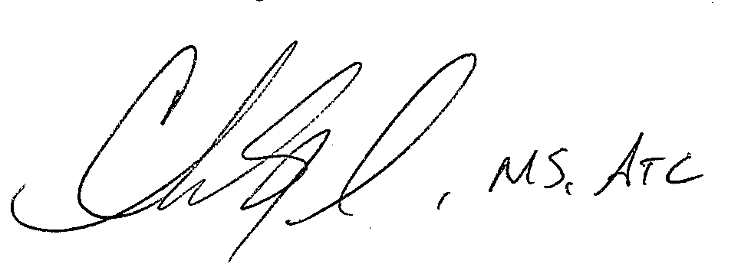

Chris Siegel – Development Director
320-808-9238
development@mnata.com

Troy Hoehn - President Theresa Mackey – President-Elect
president@mnata.com presidentelect@mnata.com

Aaron Benson – Vice President Kate Taber– Secretary
vicepresident@mnata.com secretary@mnata.com

Neal Dutton – GLATA Representative Chris Siegel - Treasurer
staterep@mnata.com treasurer@mnata.com
2018 Minnesota Athletic Trainers Association Sponsorship Opportunities
Annual Meeting and Clinical Symposium Sponsorship – April 27 & 28

 | Recognition of Sponsorship Level | Signage | Verbal Recognition | Logo with Direct Link on MATA Website | Display Table in Annual Meeting Exhibitor Space | Complimentary Registrations to 2018 Annual Meeting | Advertising in MATA Monthly E-blast | Student Symposium Sponsorship | Golf Sponsorship
Feature  Sponsorship with Eagle Golf  $2,200 | Feature  Sponsor Recognition | Individual Recognition and logo displayed during general session | Opening Remarks, Business Meeting, Closing Remarks | Home Page, Annual Meeting Page, Sponsorship Page | One Display Table with premium location | Two (2)  Registration | Four (4)  Annual | Complimentary Ad in Student Symposium Packet & Logo on Student Page of MATA Website | Complimentary  Eagle  Sponsorship
Feature  Sponsorship  $2,000 | Feature  Sponsor  Recognition | Individual Recognition and logo displayed during general session | Opening Remarks, Business Meeting, Closing Remarks | Home Page, Annual Meeting Page, Sponsorship Page | One Display Table with premium location | Two (2)  Registration | Four (4)  Annual | Complimentary Ad in Student Symposium Packet & Logo on Student Page of MATA Website | Complimentary  Birdie Sponsorship
Presenting  Sponsor  $1,000 | Presenting  Sponsor  Recognition | Recognition and logo displayed during general session | Opening Remarks, Business Meeting, Closing Remarks | Annual Meeting Page, Sponsorship Page | One Display Table with premium location | Two (2)  Registration | Two (2)  Annual

2018 Minnesota Athletic Trainers Association Sponsorship Opportunities
Annual Meeting and Clinical Symposium Sponsorship – April 27 & 28
 | Recognition of Sponsorship Level | Signage | Verbal Recognition | Logo with Direct Link on MATA Website | Display Table in Annual Meeting Exhibitor Space | Complimentary Registrations to 2018 Annual Meeting | Advertising in MATA Monthly E-blast | Student Symposium Sponsorship | Golf Sponsorship
HOF & Awards  Banquet  Sponsor  $800 | HOF & Awards Sponsor  Recognition | Recognition and logo displayed at HOF & Awards Banquet | At opening and closing remarks of Banquet | Honors and Awards Page, Annual Meeting Page, Sponsorship Page | One Display Table | One (1)  Registration | One (1)  Annual
Gold Sponsor  $500 | Gold Sponsor Recognition | Sponsor level list displayed upon entrance to general session meeting space | Business Meeting | Annual Meeting Page, Sponsorship Page | One Display Table
Social  Sponsor  $400  (Max. 2) | MATA Social Sponsor Recognition | Recognition displayed upon entrance to the Social | At remarks during Social | Annual Meeting Page, Sponsorship Page | One Display Table
Silver  Sponsor  $300 | Silver Sponsor Recognition | Sponsor level list displayed upon entrance to general session meeting space | Business Meeting | Sponsorship Page

2018 Minnesota Athletic Trainers Association Sponsorship Opportunities
Golf Tournament Sponsorship – Bunker Hills Golf Course – Wednesday June 20, 2018
 | Golf and Dinner | Signage | Verbal Recognition | Logo with Direct Link on MATA Website
Presenting – Naming  Sponsor  $1,500  This Sponsorship Level has been Awarded | Four (4) free tournament entries with dinners | Sign recognition at the assembly area and dinner | Opening Remarks and Dinner | Golf Page, Sponsorship Page
Eagle Sponsor  $1,000 | Four (4) free tournament entries with dinners | Sponsorship of a hole  and a hole contest ** | Dinner | Golf Page, Sponsorship Page
Birdie Sponsor  $800 | Four (4) free tournament entries with dinners | Sign recognition at a tee box | Dinner | Golf Page, Sponsorship Page
Par Sponsor  $400 | Two (2) free tournament entries with dinners | Recognition at the registration table | Dinner | Golf Page, Sponsorship Page

** Sponsorship of a hole contest during the MATA Golf Tournament
  - Sponsor will have the opportunity to set up on one of the holes gaining direct access to ALL participants in the event at the hole of their contest
  - Sponsor will provide prize for contest winner (value $200 or greater)
  - Example: Chipping contest: Players would chip into a medical kit. Everyone that gets a ball in the kit has a chance of winning the kit (value of $200 or greater). Everyone that tries receives a small logoed item with the logo from the sponsor if you choose
  - We are open to contest ideas. The first to sign up for this level of sponsorship has first choice in what their hole contest will be

2018 Minnesota Athletic Trainers Association Sponsorship Opportunities
Student Symposium – Bethel University - January 26 & 27
 | Recognition of Sponsorship Level | Verbal Recognition | LOGO with Direct Link on MATA Website | Display Table in Annual Meeting Exhibitor Space | Advertising in MATA Monthly E-Blast
Presenting Sponsor  $250 | Presenting Sponsor Recognition | Opening Remarks,  Closing Remarks | Student Page, Sponsorship Page | Display Table for products  or services | Advertising for one (1)  regular  E-Blasts

